**Introduction**

Correlation of the chemical shift with substituent constant has been widely used to investigate the nature of the effect of the substituent on the physical properties of compounds. Electron density around the nucleus of interest (H,C) is mostly affected by the electron-donating and electron-withdrawing ability of the substituent.

Therefore, a correlation between the observed chemical shift and any parameters representing such ability seems to be well-founded and there are numerous reports on the subject1.

The most successful and intensively investigated are the linear free energy relationship with the Hammett equation2,3,4 as the most predominant example.

The single substituent parameter (SSP) approach which is represented by equation (1) has been used to correlate the chemical shift of m- and p- substituted compound to unsubstituted compound using the Hammett *σm*and *σp* values. Values of 13C were reported for the system of m- and p- substituted cinnamic acids2.

*δ = ρσ + δo* (1)

The dual substituent parameter (DSP) approach on the other hand, divides the effect of substituent into inductive (σI) and resonance (σR) parameters as represented in equation (2).

*δ = ρIσI + ρRσR +δo* (2)

The substituent constant σ measures the polar effect of the substituent and is, in principle, independent of the nature of the reaction. The reaction constant ρ depends on the nature of the reaction and measures the susceptibility of the reaction to polar effects of the substituents.

Electron-withdrawing substituents have positive values of σ electron-releasing substituents have negative values. The σ- scale covers roughly the numerical range 0±14. The reaction constant ρ, measures the susceptibility of the reaction to the influence of substituents.

Yukawa and Tsuno5 proposed equation (3) for dealing with the influence of +M substituents on reactions which are more electron demanding than the ionization of benzoic acid.

*δ = ρσ +*r (*σ*+ - *σ*- ) *δo* (3)

The DSP analysis of sterically congested systems has been improved by TSP by using Charton’s steric parameter (ν) using equation (4).

δ *= ⍴I σI+⍴R σR*+ *φν*+δ*°* (4)

The DSP equation (2) is the most generally useful treatment and is well-suited for the analysis of spectroscopic data. In equation (2), the derived *ρI* and *ρR* values which are position dependent, give a direct measure of the relative transmission of inductive and resonance effects. Due to independence of the *ρI* and *ρR* transmission coefficients, DSP method represents a general approach for the correlation of substituent effects over a large range of different mechanisms7their relative importance may change from one system to another.

The relative importance of the resonance and inductive effects is expressed by blending factor (λ) obtained as the ratio of the coefficients r and f or *ρR*and *ρI*.

**Recent studies on substituent effects on 1H and 13C NMR chemical shifts**

G.F. Fadhil and A.H. Essa6 studied on 13C NMR chemical shifts of substituted benzylidene anilines. The benzylidene substituent dependence of δC (C=N) was used as a tool to study electronic substituent effects on azomethine unit. The benzylidene substituents X have a reverse effect on δC (C=N); electron-withdrawing substituent cause shielding, while electro-donating ones do the reverse, the resonance effects clearly predominating over the inductive effects.

R.Arulkumaran *et al.*7 reported on IR and NMR chemical shifts of substituted cyanopyridine. NMR chemical shifts were correlated with Hammett substituent constants using single and multi-linear regression constants.

R.Arulkumaran and coworkers8 synthesized substituted (E)-1-benzylidene-2-(diphenylmethylene) hydrazine compounds. They were characterized by UV,IR and NMR spectral data. These data are correlated with Hammett substituent constants and Swain-Lupton F and R parameters using single and multi-linear regression analysis.

G. Thirunarayanan *et al.*9 synthesized substituted aryl benzohydrazide and were analyzed by spectral data. These data were correlated with Hammett substituent constants and Swain-Lupton parameters using single and multi-linear regression analysis.

M.Rajarajan and co-workers10 reported UV, IR and NMR chemical shifts of substituted (E)-1-benzylidene-2-(4-bromophenyl) hydrazine. The spectral data have been correlated with various Hammett substituent constant and Swain-Lupton F and R parameters using single and multi-regression analysis.

Aleksandar D. Marinkovic *et al.*11 studied the substituent effect on IR,1H and 13C NMR spectral data of N-(substituted phenyl)-2-cyanoacetamides. A variety of substituents were employed for phenyl substitution and fairly good correlations were obtained using the simple Hammett and Hammett-Taft dual substituent parameter equations.

G.Thirunarayanan and co-workers12 reported the substituent effect on IR and NMR spectral data in 4-bromo-1-naphthyl chalcones. These spectral data are correlated with various Hammett substituent constants. From the results of statistical analysis, the effect of substituents explained.

G. Thirunarayanan13 synthesized series of diimines and studied correlation analysis of IR and NMR spectral data. The data were correlated with Hammett substituent constants and Swain-Lupton F and R parameters using single and multi-linear regression analysis.

**Purpose and scope of the present investigation**

In the present study, the substituted-5-benzylidenebarbituric acids were prepared with the following objectives.

1. To study the correlations between the Hammett substituent constants and 13C NMR substituent induced chemical shifts (SCS) of substituted-5-benzylidenebarbituric acids.
2. To study the use of SCS to monitor the transmission of electronic effects in molecular structures and to understand the mode of transmission of long-range effects in extended π-systems.

**EXPERIMENTAL**

**Preparation of Compounds**

5-benzylidenebarbituric acid and its substituted compounds were prepared by the modified procedure14.

To the calculated amount of the pure benzaldehyde (2 g, 0.015 mol) and barbituric acid (1.55g, 0.015 mol) in warm ethyl alcohol was added a 10% solution of sodium hydroxide (catalytic amount) and the reaction mixture stirred for 2 hours. After completion of the reaction as indicated by TLC, the reaction mixture was left overnight (scheme I). The solvent was removed in vacuum. The resulting crude product was purified by column chromatography.



(Scheme I)

**CHARACTERIZATION**

All the compounds were characterized as 5-benzylidenebaarbituric acid and its derivatives by 1H and 13C NMR spectral techniques. 1H and 13C spectra were obtained on a BRUKER AMX 400 MHz spectrometer. Chemical shift of 1H were measured with the peak of DMSO at δ 2.51 as the internal reference, while those of 13C were recorded with the central peak of DMSO at δ 39.90 as the internal reference.



Fig (1)

**Assignment of 1H NMR Signals**

In 1H NMR spectrum of 5-benzylidenebarbituric acid whose signals assignment were not difficult and all signals well separated from each other. The NH-proton of N8 and N11 atoms are expected to downfield than the -CH-proton of C5 carbon atom. The -CH-proton of C5 is well separated from all other protons signals, hence it’s assignment is not difficult. 1H NMR spectra of substituted 5-benzylidenebarbituric acids are given in Fig’s (2 - 8).

**1H NMR** Spectra of 5-benzylidenebarbityric acids are given below.

1. 5-(4’-Methoxybenzylidene)barbituric acid

δ 3.877 (s,3H), 7.065 (d,2H), 8.252(s,1H), 8.369 (d,2H), 11.175 (s,1H), 11.302 (s,1H).

2. 5-(4’-Hydroxybenzylidene)barbituric acid

δ 6.878 (d,2H), 8.213 (s,1H), 8.320 (d,2H), 10.851 (s,1H), 11.117(s,1H), 11.249 (s,1H).

3. 5-(4’-Methylbenzylidene)barbituric acid

δ 2.385 (s,3H), 7.304 (d,2H), 8.094 (d,2H), 8.255 (s,1H), 11.218 (s,1H), 11.365 (s,1H).

4. 5-Benzylidenebarbituric acid

δ 7.485 (m,3H), 8.073 (d,2H), 8.285 (s,1H), 11.238 (s,1H), 11.397 (s,1H).

5. 5-(4’-Chlorobenzylidene)barbituric acid

δ 7.518 (d,2H), 8.069 (d,2H), 8.243 (s,1H), 11.275 (s,1H), 11.425 (s,1H).

6. 5-(4’-Bromobenzylidene)barbituric acid

δ 7.670 (d,2H), 7.979 (d,2H), 8.223 (s,1H), 11.272 (s,1H), 11.421 (s,1H).

7. 5-(4’-Nitrobenzylidene)barbituric acid

δ 8.017 (d,2H), 8.245 (d,2H), 8.324 (s,1H), 11.329 (s,1H), 1.504 (s,1H).

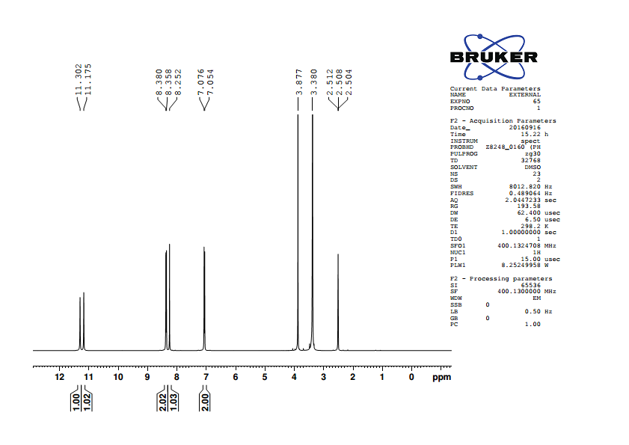

Fig.2. 1H NMR spectrum of 5-(4’-methoxybenzylidene)barbituric acid

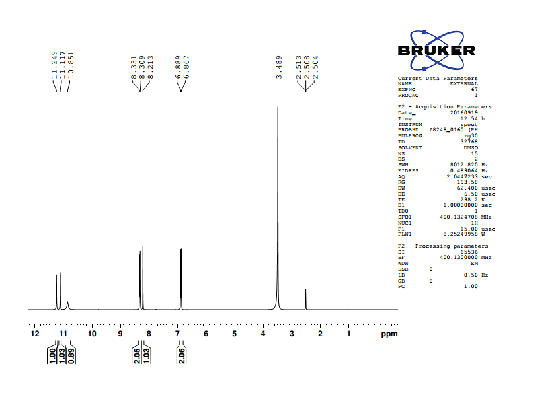

Fig.3. 1H NMR spectrum of 5-(4’-hydroxybenzylidene)barbituric acid

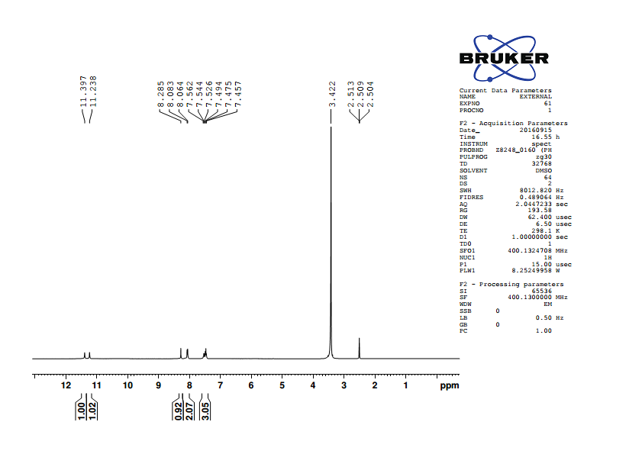

Fig.4. 1H NMR spectrum of 5-(4’-methylbenzylidene)barbituric acid

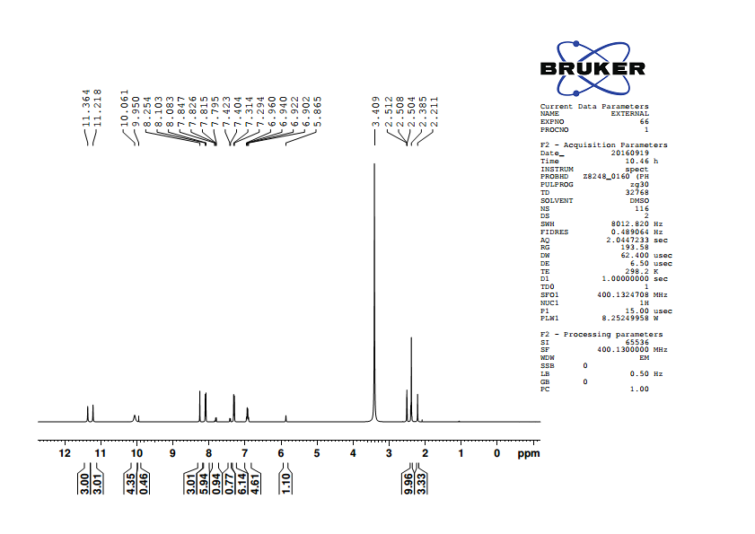

Fig.5. 1H NMR spectrum of 5-benzylidenebarbituric acid

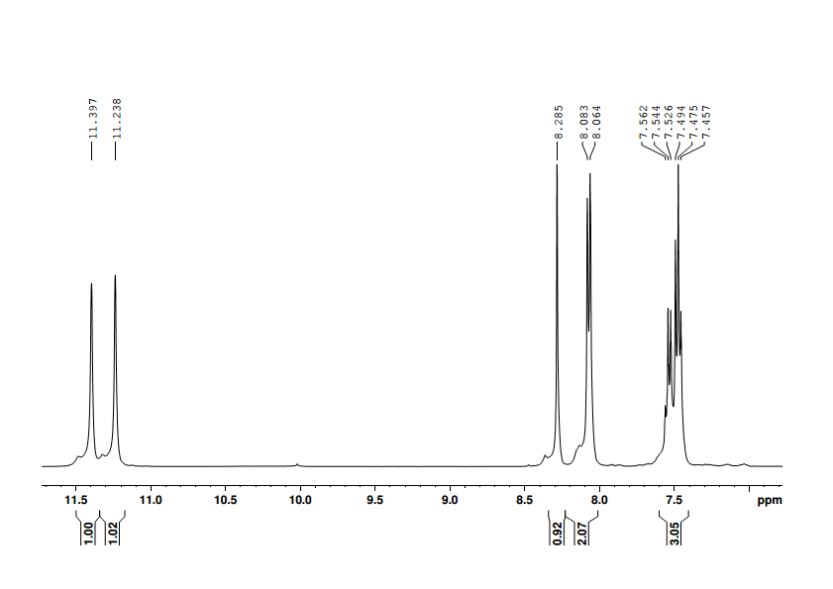

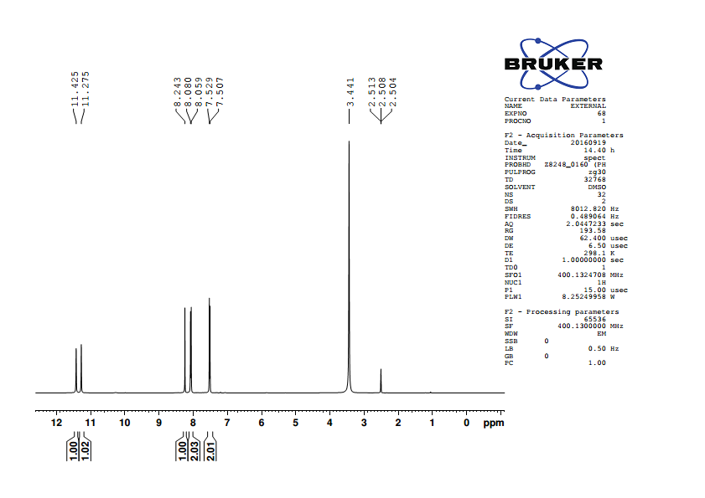

Fig.6. 1H NMR spectrum of 5-(4’-chlorobenzylidene)barbituric acid

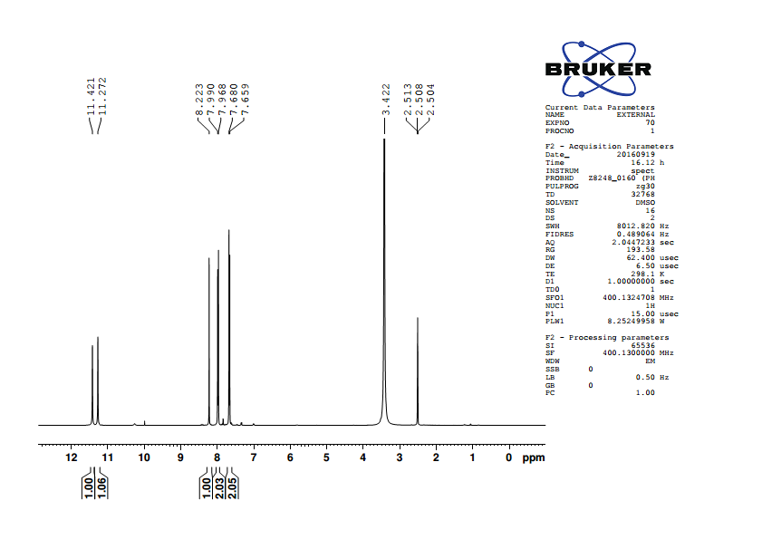

Fig.7. 1H NMR spectrum of 5-(4’-bromobenzylidene)barbituric acid

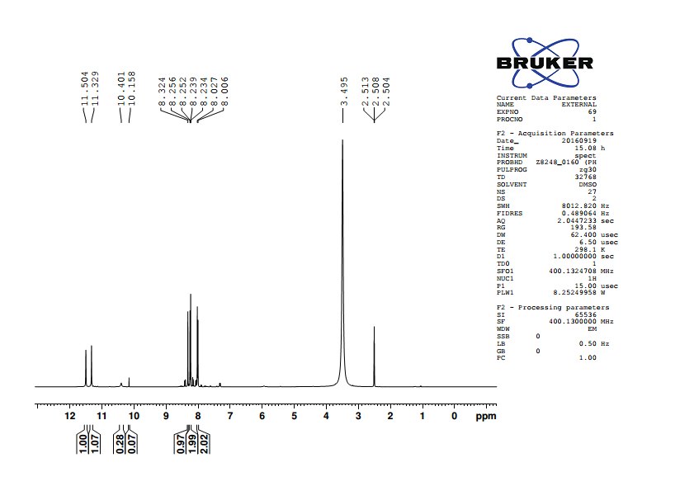

Fig.8. 1H NMR spectrum of 5-(4’-nitroobenzylidene)barbituric acid

**Table (1): 1H NMR chemical shifts of** **substituted 5-benzylidenebarbituric**

**acids**

|  |  |  |  |  |  |  |  |
| --- | --- | --- | --- | --- | --- | --- | --- |
|  |  |  |  |  |  |  |  |
| S.No. | Substituent, -X |  | H22’ | H33’ | H5 | H8 | H10 |
|  |  |  |  |  |  |  |  |
| 1. | -OCH3 |  | 7.065 | 8.369 | 8.252 | 11.175 | 11.302 |
|  |  |  |  |  |  |  |  |
| 2. | -OH |  | 6.878 | 8.32 | 8.213 | 11.117 | 11.249 |
|  |  |  |  |  |  |  |  |
| 3. | -CH3 |  | 7.304 | 8.094 | 8.255 | 11.218 | 11.365 |
|  |  |  |  |  |  |  |  |
| 4. | -H |  | 7.485 | 8.073 | 8.285 | 11.238 | 11.397 |
|  |  |  |  |  |  |  |  |
| 5. | -Cl |  | 7.518 | 8.069 | 8.243 | 11.275 | 11.425 |
|  |  |  |  |  |  |  |  |
| 6. | -Br |  | 7.670 | 7.979 | 8.223 | 11.272 | 11.421 |
|  |  |  |  |  |  |  |  |
| 7. | -NO2 |  | 8.245 | 8.017 | 8.324 | 11.329 | 11.504 |

**H5 – Hydrogen atom**

The chemical shift of H5 hydrogen appeared over a relatively very narrow range of 0.111 ppm. The SSP analysis of H5 hydrogen atom gave poor correlation with *σp****,*** *σp+/ σp-, σp+/ σp/ σp-* (Table. 2). The best fit of SSP analysis is given in equation (5).

log δH5 **=** 0.002 *σp+/ σp-* + 0.916 (5)

(±0.001) (±0.001)

r = 0.746; s = 0.001; F = 6.29; n = 7

The result of DSP analysis is given in table (3) and the best fit of DSP analysis is given in equation (6).

log δ H5 **=** 0.001 *σI* + 0.006 *σRo* **+** 0.917 (6)

(±0.001) (±0.001) (±0.001)

R = 0.923; SE = 0.001; F = 2.05; n = 6

**H8 – Hydrogen atom**

The chemical shift of H8  hydrogen appeared over a narrow range of

0.159 ppm. The SSP analysis of H8 hydrogen atom gave good correlations with σp, σpo, σp+, σp+/ σp- (Table .2). The best fit of SSP analysis is given in equation (7). The plot of log δH8 vs *σp+* is shown in Fig. (9).

log δ H8 **=** 0.004 *σp+* + 1.05 (7)

(±0.001)

r = 0.975; s = 0.001; F = 27.35; n =6

**Table (2): Results of statistical treatment of 1H – Chemical shift with σp,σpo,**

**σp+, σp+/ σp, σp+/ σp-, σp+/ σp/ σp- substituent constants using single**

**parameter equation**

|  |  |  |  |  |  |  |  |  |
| --- | --- | --- | --- | --- | --- | --- | --- | --- |
| **S.No** | **Protons** | **Scale** | **ρ** | **r** | **s** | **F** | **log δo** | **n** |
| 1 | H5 | *σP* | 0.003±0.002 | 0.658 | 0.002 | 3.81 | 0.917±0.001 | 7 |
|  | *σPO* | 0.003±0.002 | 0.550 | 0.002 | 1.74 | 0.916±0.001 | 6 |
|  | *σP+* | 0.002±0.001 | 0.679 | 0.002 | 4.27 | 0.917±0.001 | 7 |
|  | *σP+/ σP* | 0.002±0.001 | 0.535 | 0.002 | 2.01 | 0.916±0.001 | 7 |
|  | *σP+/ σP-* | 0.002±0.001 | 0.746 | 0.001 | 6.29 | 0.916±0.001 | 7 |
|  | *σP+/ σP/ σP-* | 0.002±0.001 | 0.650 | 0.002 | 3.66 | 0.916±0.001 | 7 |
|  |  |  |  |  |  |  |  |  |
| 2 | H8 | *σP* | 0.007±0.001 | 0.940 | 0.001 | 38.04 | 1.050±0.001 | 7 |
|  | *σPO* | 0.005±0.001 | 0.934 | 0.001 | 27.35 | 1.050±0.001 | 6 |
|  | *σP+* | 0.004±0.001 | 0.975 | 0.001 | 99.39 | 1.050±0.001 | 7 |
|  | *σP+/ σP* | 0.005±0.001 | 0.877 | 0.001 | 16.67 | 1.050±0.001 | 7 |
|  | *σP+/ σP-* | 0.003±0.001 | 0.942 | 0.001 | 39.58 | 1.051±0.001 | 7 |
|  | *σP+/ σP/ σP-* | 0.004±0.001 | 0.856 | 0.001 | 13.72 | 1.050±0.001 | 7 |
|  |  |  |  |  |  |  |  |  |
| 3 | H10 | *σP* | 0.008±0.001 | 0.948 | 0.001 | 44.25 | 1.055±0.001 | 7 |
|  | *σPO* | 0.006±0.001 | 0.917 | 0.001 | 21.26 | 1.055±0.001 | 6 |
|  | *σP+* | 0.005±0.001 | 0.999 | 0.0005 | 245.58 | 1.056±0.001 | 7 |
|  | *σP+/ σP* | 0.006±0.001 | 0.903 | 0.002 | 22.20 | 1.056±0.001 | 7 |
|  | *σP+/ σP-* | 0.004±0.001 | 0.962 | 0.001 | 62.96 | 1.056±0.001 | 7 |
|  | *σP+/ σP/ σP-* | 0.004±0.001 | 0.887 | 0.002 | 18.44 | 1.055±0.001 | 7 |
|  |  |  |  |  |  |  |  |  |
| 4 | H22’ | *σO* | 0.057±0.016 | 0.838 | 0.02 | 11.81 | 0.865±0.006 | 7 |
|  | *σO\** | 0.052±0.007 | 0.966 | 0.007 | 56.20 | 0.864±0.003 | 6 |
|  | *Es* | -0.041±0.012 | 0.831 | 0.016 | 11.16 | 0.876±0.006 | 7 |

**Table (3 ): DSP analysis of 1H-chemical shift data with dual parameter equations (16) and (17).**

|  |  |  |  |  |  |  |  |  |  |  |
| --- | --- | --- | --- | --- | --- | --- | --- | --- | --- | --- |
| **S.No** | **Protons** | **Scale** | ***ρI*** | ***ρR*** | **R** | **SE** | **F** | **log δo** | **n** | **λ=ρR/ρI** |
|
| 1 | H5 | *σI ,σR* | 0.001±0.003 | 0.005±0.003 | 0.711 | 0.002 | 2.05 | 0.917±0.001 | 7 | 5.00 |
|  |  | *σI ,σRo* | 0.001±0.001 | 0.006±0.001 | 0.923 | 0.001 | 8.50 | 0.917±0.001 | 6 | 6.00 |
|  |  | *σI ,σR+* | -0.001±0.004 | 0.002±0.002 | 0.384 | 0.002 | 0.35 | 0.918±0.002 | 7 | 2.00 |
|  |  | *σI ,σR-* | -0.001±0.001 | 0.005±0.001 | 0.905 | 0.001 | 6.85 | 0.918±0.001 | 6 | 50.00 |
|  |  | *F,R* | 0.001±0.002 | 0.005±0.002 | 0.783 | 0.002 | 3.17 | 0.917±0.001 | 7 | 8.33 |
|  |  |  |  |  |  |  |  |  |  |  |
| 2 | H8 | *σI ,σR* | 0.005±0.002 | 0.008±0.002 | 0.879 | 0.002 | 6.88 | 1.051±0.001 | 7 | 1.60 |
|  |  | *σI ,σRo* | 0.005±0.002 | 0.003±0.002 | 0.838 | 0.001 | 3.54 | 1.056±0.001 | 6 | 0.60 |
|  |  | *σI ,σR+* | 0.002±0.002 | 0.002±0.002 | 0.609 | 0.003 | 1.18 | 1.050±0.003 | 7 | 0.66 |
|  |  | *σI ,σR-* | 0.004±0.002 | 0.003±0.002 | 0.883 | 0.001 | 5.31 | 1.050±0.001 | 6 | 0.75 |
|  |  | *F,R* | 0.004±0.002 | 0.008±0.001 | 0.966 | 0.001 | 27.96 | 1.051±0.001 | 7 | 2.00 |
|  |  |  |  |  |  |  |  |  |  |  |
| 3 | H10 | *σI ,σR* | 0.005±0.003 | 0.010±0.002 | 0.912 | 0.002 | 9.89 | 1.056±0.001 | 7 | 2.00 |
|  |  | *σI ,σRo* | 0.006±0.003 | 0.005±0.003 | 0.829 | 0.002 | 3.29 | 1.056±0.001 | 6 | 0.83 |
|  |  | *σI ,σR+* | 0.003±0.006 | 0.003±0.003 | 0.622 | 0.003 | 1.27 | 1.056±0.003 | 7 | 1.00 |
|  |  | *σI ,σR-* | 0.005±0.002 | 0.005±0.002 | 0.886 | 0.001 | 5.47 | 1.056±0.001 | 6 | 1.00 |
|  |  | *F,R* | 0.005±0.001 | 0.010±0.001 | 0.984 | 0.001 | 63.96 | 1.057±0.001 | 7 | 2.00 |
|  |  |  |  |  |  |  |  |  |  |  |
| 4 | H22’ | *σI ,σR* | 0.047±0.015 | 0.077±0.015 | 0.950 | 0.010 | 18.69 | 0.873±0.007 | 7 | 1.60 |
|  |  | *σI ,σRo* | 0.057±0.025 | 0.041±0.024 | 0.851 | 0.020 | 3.93 | 0.868±0.011 | 6 | 0.66 |
|  |  | *σI ,σR+* | 0.030±0.004 | 0.023±0.021 | 0.684 | 0.020 | 1.76 | 0.872±0.022 | 7 | 0.66 |
|  |  | *σI ,σR-* | 0.042±0.015 | 0.047±0.012 | 0.951 | 0.010 | 14.96 | 0.871±0.006 | 6 | 1.25 |
|  |  | *F,R* | 0.05±0.006 | 0.073±0.005 | 0.992 | 0.040 | 132.74 | 0.874±0.003 | 7 | 1.40 |

The DSP analysis is given in table (3) and the best fit of DSP analysis is given in equation (8).

log δH8  = 0.004 *F* + 0.008 *R* + 1.051 (8)

(±0.002) (±0.001) (0.001)

R = 0.966; SE = 0.001; F = 27.96; n = 7

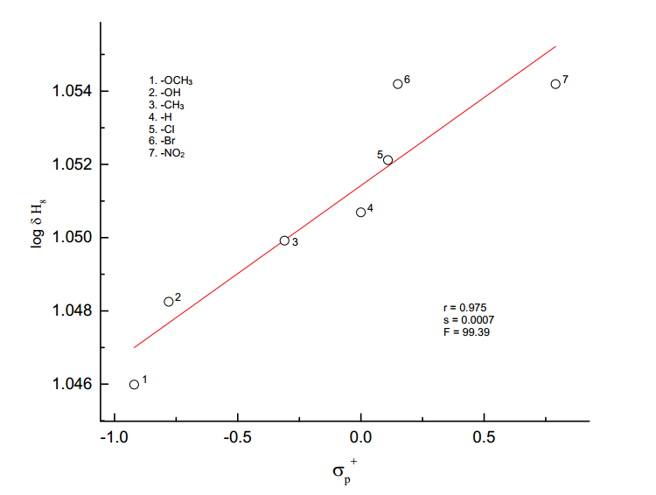

**Fig. 9. The plot of log δH8  vs *σp+***

**H10 – Hydrogen atom**

The chemical shift of H10 hydrogen atom shows a range of about 0.255 ppm. The result of SSP analysis shown in table (2), afford an excellent correlation by *σp+* constant given in equation (9), and the plot of log δ H10 vs *σp+* is shown in Fig. (10).

log δ H10  = 0.005 *σp+* + 1.056 (9)

(±0.001) (±0.001)

r = 0.999; s = 0.0005; F = 245.58; n = 7

The DSP analysis on table (3), afford an excellent correlation is shown in equation (10).

log δ H10  = 0.005 *F* + 0.010 *R* + 1.057 (10)

(±0.001) (±0.001) (0.001)

R = 0.984; SE = 0.001; F = 63.96; n = 7

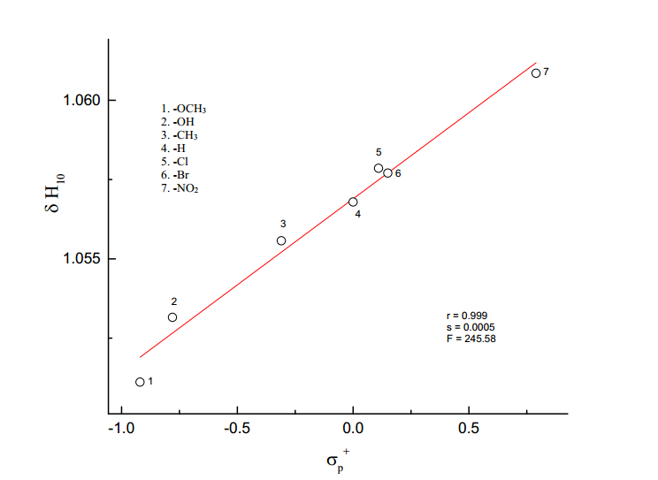

log

**Fig. 10. The plot of log δH10 vs *σp+***

**H22’ – Hydrogen atom**

The chemical shift of H22’ hydrogen atom shows a range of about 1.367 ppm. The result of SSP analysis shown in table (2), afford a satisfactory correlation with σo* constant given in equation (11).

log δ H22’  = 0.052 *σo\** + 0.865 (11)

(±0.007) (±0.003)

r = 0.966; s = 0.007; F = 56.20; n = 6

The result of DSP analysis is given in Table (3) and the best fit of DSP analysis is given in equation (12).

log δ H22’  = 0.049*F* + 0.073*R* + 0.874 (12)

(±0.006) (±0.005) (±0.003)

R = 0.992; SE = 0.04; F = 132.74; n = 7

The result of TSP is given in table (4) and the best fit of TSP analysis and the results are given in equation (13).

log δ H22’  = -0.035 *σI* + 0.029 *σR*+ + 0.045 ν + 0.875 (13)

(±0.019) (±0.038) (±0.061) (±0.003)

R = 0.998; s = 0.039; n = 6

A better description of the composition of electrical effect is given by the equation (14).

PR = (14)

PR  is the percentage of delocalized effect. The value of PR is found to be 27.10. The magnitude of steric factor is given by the equation (15),

PS = (15)

The magnitude of the steric effect is given by the quantity PS. The value of PS is found to be 40.19, which shows that steric effect is also operating to some extent.

**Table (4): TSP analysis of SCS data of H22’ hydrogen atom of** **substituted**

**5-benzylidenebarbituric acids employing equation (4).**

|  |  |  |  |  |  |  |  |
| --- | --- | --- | --- | --- | --- | --- | --- |
|  |  |  |  |  |  |  |  |
| S.No. | Scale | α | β | φ | r | s | n |
|  |  |  |  |  |  |  |  |
|  |  |  |  |  |  |  |  |
| 1. | *σI ,σRo,ν* | 0.037  (±0.051) | 0.032  (±0.030) | 0.152  (±0.032) | 0.866 | 0.017 | 6 |
|  |  |  |  |  |  |  |  |
| 2. | *σI, σR+, ν* | -0.035  (±0.008) | 0.029  (±0.002) | 0.043  (±0.004) | 0.996 | 0.029 | 6 |
|  |  |  |  |  |  |  |  |
| 3. | *F, R, ν* | 0.041  (±0.012) | 0.070  (±0.007) | 0.006  (±0.001) | 0.994 | 0.004 | 7 |
|  |  |  |  |  |  |  |  |

**Assignment of 13C NMR signals**

13C NMR signals were assigned for various carbons were based on the

1. Chemical shift exhibited by the signals
2. Relative signal intensity
3. Empirical additivity rules

13C NMR spectrum of 5-benzylidenebarbituric acid contains 9 signal corresponding to 9 different carbon atoms. In all the spectra, carbonyl carbon signal was readily recognized and also well separated from other signals to downfield extreme, since its assignment was not difficult. 13C NMR spectra of substituted

5-benzylidenebarbituric acids are given in fig’s (11-17).

**13C NMR Spectra of 5-benzylidenebarbituric acids**

1*.* 5-(4’-Methoxybenzylidene)barbituric acid

δ 56.22, 114.41, 116.00, 125.62, 137.96, 150.67, 155.46, 162.64, 163.92, 164.39.

2. 5-(4’-Hydroxybenzylidene)barbituric acid

δ 114.61, 115.97, 124.24, 138.77, 150.70, 156.05, 162.75,163.48, 164.59.

3. 5-(4’-Methylbenzylidene)barbituric acid

δ 118.30, 129.33, 130.31, 134.43, 143.96, 150.68, 155.46, 162.26, 164.08.

4. 5-Benzylidenebarbituric acid

δ 119.55, 128.52, 132.69, 133.11, 133.54, 150.69, 155.20, 162.03, 163.87.

5. 5-(4’-Chlorobenzylidene)barbituric acid

δ 120.09, 128.55, 132.01, 135.15, 137.21, 150.65, 153.52, 162.04, 163.67.

6. 5-(4’-Bromobenzylidene)barbituric acid

δ 120.24, 126.29, 131.51, 132.40, 135.15, 150.65, 153.56, 162.04, 163.67.

7. 5-(4’-Nitrobenzylidene)barbituric acid

δ 123.15, 123.37, 132.69, 140.48, 148.49, 150.68, 151.63, 161.62, 163.13.

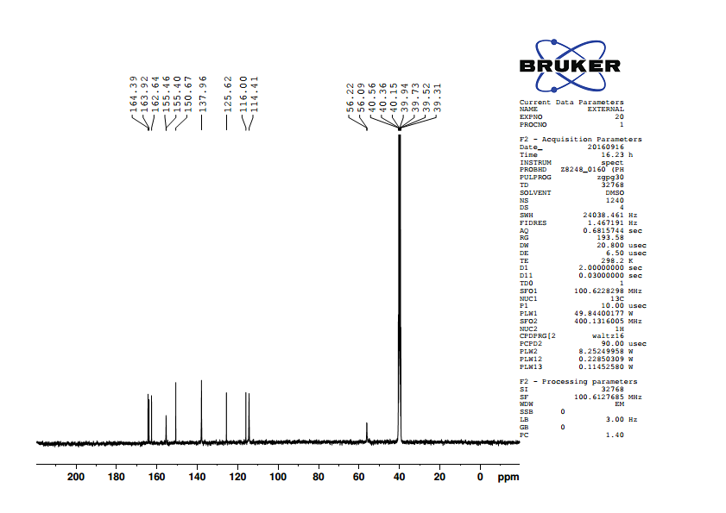

Fig.11. 13C NMR spectrum of 5-(4’-methoxybenzylidene)barbituric acid

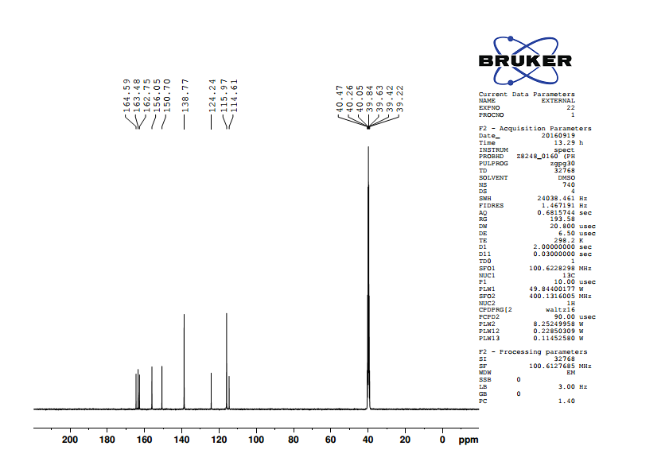

Fig.12. 13C NMR spectrum of 5-(4’-hydroxybenzylidene)barbituric acid

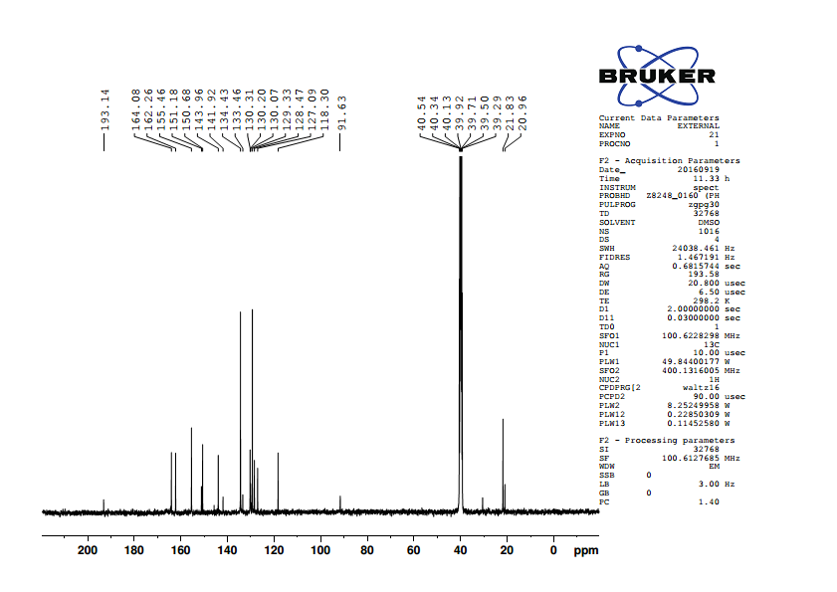

Fig. 13. 13C NMR spectrum of 5-(4’-methylbenzylidene)barbituric acid

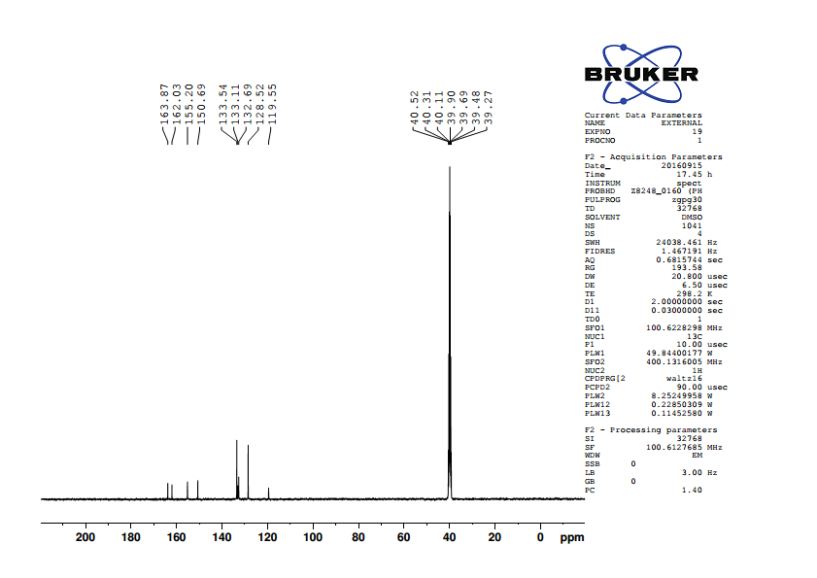

Fig.14. 13C NMR spectrum of 5-benzylidenebarbituric acid

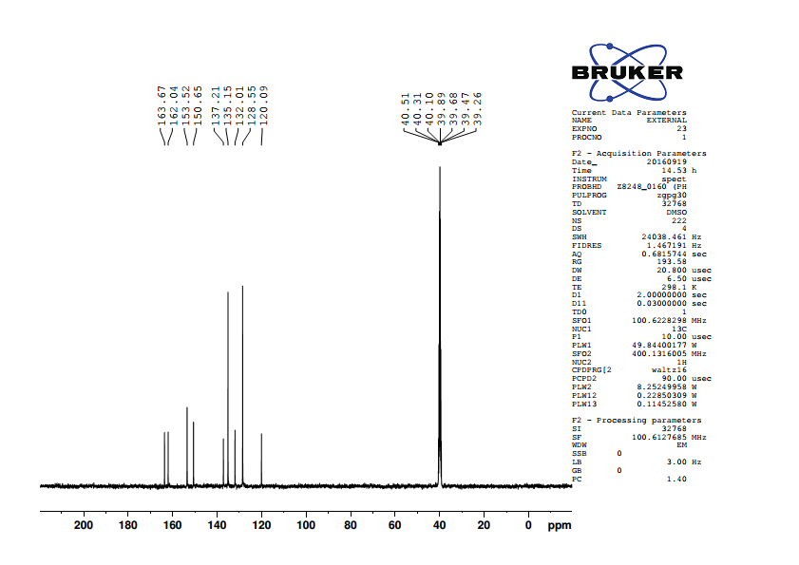

Fig. 15. 13C NMR spectrum of 5-(4’-chlorobenzylidene)barbituric acid

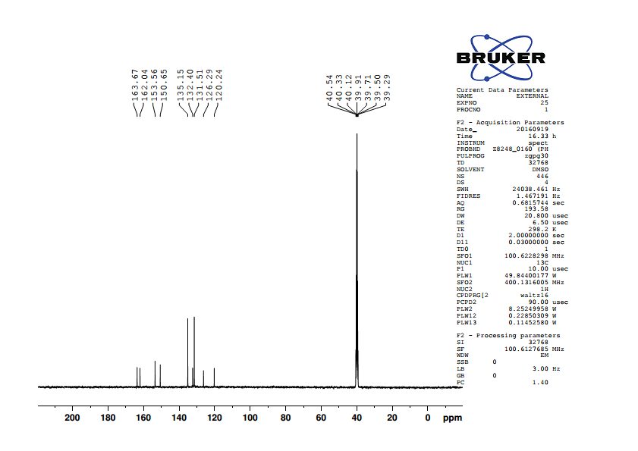

Fig. 16. 13C NMR spectrum of 5-(4’-bromobenzylidene)barbituric acid

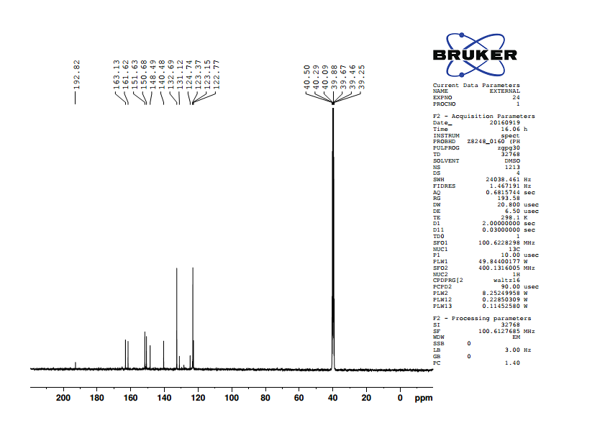

Fig.17. 13C NMR spectrum of 5-(4’-nitrobenzylidene)barbituric acid

**Table (5): 13C NMR chemical shifts of substituted 5-benzylidenebarbituric acids**

|  |  |  |  |  |  |  |  |  |  |  |
| --- | --- | --- | --- | --- | --- | --- | --- | --- | --- | --- |
| **S.No.** | *p*-X | **C1** | **C22’** | **C33’** | **C4** | **C5** | **C6** | **C7** | **C9** | **C11** |
|  |  |  |  |  |  |  |  |  |  |  |
| 1 | -OCH3 | 162.64 | 114.41 | 137.96 | 125.62 | 155.46 | 116 | 163.92 | 150.67 | 164.39 |
|  |  |  |  |  |  |  |  |  |  |  |
| 2 | -OH | 163.48 | 115.97 | 138.77 | 124.24 | 156.05 | 114.61 | 162.75 | 150.7 | 164.59 |
|  |  |  |  |  |  |  |  |  |  |  |
| 3 | -CH3 | 143.96 | 129.33 | 134.43 | 130.31 | 155.46 | 118.3 | 162.26 | 150.68 | 164.08 |
|  |  |  |  |  |  |  |  |  |  |  |
| 4 | -H | 133.11 | 128.52 | 133.54 | 132.69 | 155.2 | 119.55 | 162.03 | 150.69 | 163.87 |
|  |  |  |  |  |  |  |  |  |  |  |
| 5 | -Cl | 137.21 | 128.55 | 135.15 | 132.01 | 153.52 | 120.09 | 162.04 | 150.65 | 163.67 |
|  |  |  |  |  |  |  |  |  |  |  |
| 6 | -Br | 126.29 | 131.51 | 135.15 | 132.4 | 153.56 | 120.24 | 162.04 | 150.65 | 163.67 |
|  |  |  |  |  |  |  |  |  |  |  |
| 7 | -NO2 | 148.49 | 132.69 | 123.37 | 140.48 | 151.63 | 123.15 | 161.62 | 150.68 | 163.13 |

**RESULTS AND DISCUSSION**

**Correlations with Lynch-Equation**

The SCS of mono substituted benzenes have been very useful in signal assignment of poly substituted compounds15-18. However, in many published studies summarized by Craik19 it has been apparent that the SCS values of X and Y at positions 4’ and 1’ in disubstituted benzenes Fig. (18) are non-additive. Lynch20 has proposed that the non-additivity of the chemical shifts of C-1’ and C-4’ is reflected in the relationship Eq. (16) where SCSX(Y) is the substituent chemical shift of the carbon



Fig. (18)

SCSX (Y) = a + b [ SCSX (H)] (16)

*para-* to X in the series of 1’,4’-disubstituted benzenes (Fig. 25, X, Y ≠ H), SCSX(H) is the corresponding substituent chemical shift of the carbon *para* to X in mono substituted benzenes (Fig. 18, Y=H), ‘b’ is the slope parameter and ‘a’ is the shift calculated for the parent spices with X=Y. A wide range of successful correlations (using Lynch equation) have been established for the SCS of carbons bearing Y in Fig. (18) with the value of ‘b’ ranging from 0.6 to 1.521. When the slope is close to unity, experimental results could be reproduced by additivity relationship and when b ≠ 1, the Lynch equation can be used to predict the SCS values through proportionality relationships. The slope b of the Lynch equation Eq. (25) is less than one, then the fixed substituent at C-1’ Fig (18) diminishes the substituent effect. When slope b is larger than one, showing that the fixed substituent undergoes an amplification of the substituent effect.

In case of C1 there is good correlation with (r=0.988) appropriate SCS (Si) values, slope b is 0.97, which reveals that the fixed substituent Y=-CH-C-C3H2N2O3, has little effect on the additivity of this shifts21.

A satisfactory correlation exists between SCS of C22’ and So with correlation coefficient (r=0.828) and the slope value (b=0.84), indicating that the fixed substituent Y, significantly diminishes the substituent effect21.

A poor correlation exists between SCS of C33’ and Sm with correlation coefficient (r=0.113) and the slope value (b=0.71) which reveals that the fixed substituent Y diminishes the substituent effect21.

The C4 carbon afford a good correlation with Sp with correlation coefficient r=0.993 and the slope value b=0.94 demonstrates that the fixed substituent Y has little effect on the additivity of these shifts21. The results of Lynch correlations are given in table (6) and the plots of Lynch correlations shown in fig. (19) and (20).

**Table (6) : Results of Lynch correlationsa of 13C chemical shifts of compound**

**fig (1) with SCS values for mono substituted benzenes.**

|  |  |  |  |  |  |  |  |
| --- | --- | --- | --- | --- | --- | --- | --- |
| S.No. | Carbons | Benzene  SCS  (Sb) | Slope  (b) | Intercept  (a) | rc | nd | se |
| 1. | C1 | Si | 0.97 | 132.23 | 0.988 | 6 | 2.17 |
|  |  |  |  |  |  |  |  |
| 2. | C22’ | SO | 0.84 | 129.73 | 0.828 | 6 | 4.14 |
|  |  |  |  |  |  |  |  |
| 3. | C33’ | Sm | 0.71 | 132.69 | 0.113 | 6 | 5.63 |
|  |  |  |  |  |  |  |  |
| 4. | C4 | Sp | 0.94 | -126.43 | 0.993 | 6 | 0.61 |

1. SCSX (Y) = a + b SCSX (H)
2. SCS values in Appendix (I)
3. Correlation coefficient
4. Number of data points
5. Standard deviations

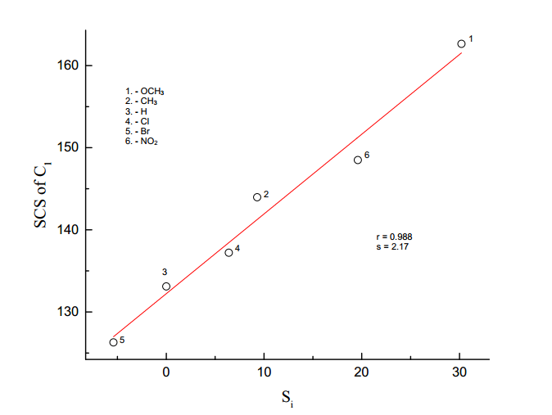

**Fig. (19).** Lynch plot of SCS of C1 vs Si

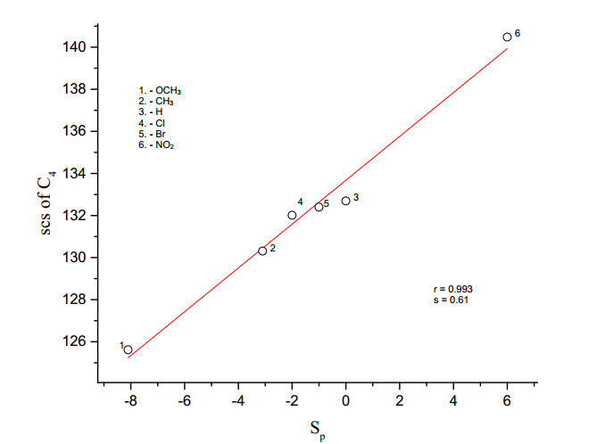

**Fig. (20).** Lynch plot of SCS of C4 vs Sp

**Substituent effects on the 13C NMR chemical shifts of the substituted**

**5-benzylidenebarbituric acids**

The use of 13C NMR SCS is to monitor the transmission of electroniceffectsin molecular frame works in general and to understand the mode of transmission of long-range substituent effects in extended π-electron systems in particular are topics of current interest. Thus long-range 13C SCS have been reported for N-benzylideneanilines22, N-benzylidenebensylamines23, chalcones24, benzophenones25, phenylacetylenes26,β-nitrostyrenes27,28, cinnamic acids29,30, cinnamates31, benzonitrile6, cyanopyridine7, (E)-1-benzylidene-2-(diphenyl methylene) hydrazines8, aryl hydrazides9,(E)-1-benzylidene-2-(4-bromophenyl) hydrazines10, N-(substituted phenyl)-2-cyano acetamides11, 4-bromo-1-naphthyl chalcones12 and symmetrical diimines13.

In this chapter, the 13C chemical shift data of several carbon atoms of 5-benzylidenebarbituric acid has been correlated with SSP equation (Eq.1), DSP equations (Eq.2) and Yukawa-Tsuno equation (Eq.3)

**C4 - Carbon atom**

The Chemical shift of C4 carbon appeared over a relatively narrow range of 16.24 ppm. The result of SSP analysis shown in table (7), an excellent correlation afford by σp+ / σp- constant given in equation (17), and the plot of log δ C4 vs σp+ / σp-  as shown in Fig (21).

log δ C4 = 0.024 σp+ / σp- + 2.118 (17)

(±0.002) (±0.001)

r = 0.989; s = 0.003; n = 7

The result of DSP analysis in table (8), afford an excellent correlation are shown in equations (18) and (19).

log δ C4 = 0.024σI + 0.051σR + 2.122 (18)

(±0.003) (±0.003) (±0.001)

R = 0.995; SE = 0.002; n = 6: F = 154.44

log δ C4 = 0.025F + 0.054R + 2.123 (19)

(±0.003) (±0.002) (±0.001)

R = 0.996; SE = 0.002; n = 7; F = 279.61

The sign of *ρ*I and *ρ*R are positive, reveals that the normal substituent effect operates on C4 carbon atom, i.e., an electron withdrawing substituent decrease the C4 carbon atom shielding and an electron releasing substituent increase it. Examination of chemical shift of data in table (5), electron-withdrawing substituent causes

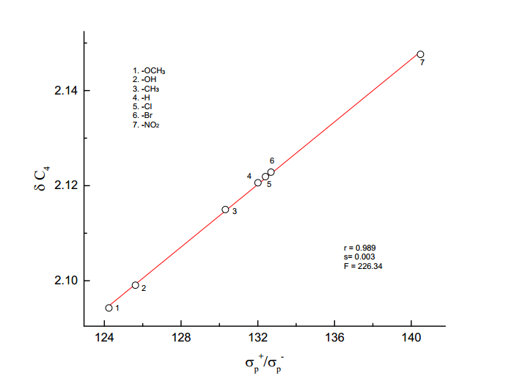

log

**Fig. 21. The plot of log δ C4 vs σp+ / σp-**

downfield shift and electron releasing substituent causes up field. The magnitude of *ρ*R is greater than *ρ*I indicate that the predominance of resonance effect over inductive effect in the chemical shift of C4 carbon atom.

This result is also shown from Yukawa-Tsuno equation (3) is given in table (9).

The result of best fit eq. (3) is given in equation (20)

log δC4 = 0.028 σp + 0.032 ( σp+- σp) + 2.12 (20)

(±0.006) (±0.009) (±0.002)

R = 0.986; SE = 0.003; n = 7; F = 72.76

**Table ( 7): Results of statistical treatment of 13C – Chemical shift with σp, σpo**

**,σp+, σp+/ σp, σp+/ σp-,σp+/ σp/ σp-substituent constants using single**

**parameter equation (1)**

|  |  |  |  |  |  |  |  |  |
| --- | --- | --- | --- | --- | --- | --- | --- | --- |
| **S.No.** | **Carbons** | **Scale** | **ρ** | **r** | **s** | **F** | **log δo** | **n** |
|  |  |  |  |  |  |  |  |  |
|  |  |  |  |  |  |  |  |  |
| 1 | C4 | *σp* | 0.043±0.006 | 0.949 | 0.006 | 43.33 | 2.115±0.002 | 7 |
|  | *σpO* | 0.038±0.010 | 0.882 | 0.008 | 13.99 | 2.114±0.004 | 6 |
|  | *σp+* | 0.029±0.002 | 0.986 | 0.003 | 179.37 | 2.121±0.001 | 7 |
|  | *σp+/ σp* | 0.033±0.006 | 0.924 | 0.007 | 29.11 | 2.117±0.003 | 7 |
|  | *σp+/ σp-* | 0.024±0.002 | 0.989 | 0.003 | 226.34 | 2.118±0.001 | 7 |
|  | *σp+/ σp/ σp-* | 0.026±0.004 | 0.938 | 0.006 | 37.12 | 2.115±0.002 | 7 |
|  |  |  |  |  |  |  |  |  |
| 2 | C5 | *σp* | -0.011±0.001 | 0.984 | 0.001 | 152.18 | 2.189±0.001 | 7 |
|  | *σpO* | -0.015±0.001 | 0.988 | 0.001 | 163.39 | 2.190±0.001 | 6 |
|  | *σp+* | -0.007±0.001 | 0.916 | 0.002 | 25.94 | 2.187±0.001 | 7 |
|  | *σp+/ σp* | -0.008±0.002 | 0.887 | 0.002 | 18.40 | 2.188±0.001 | 7 |
|  | *σp+/ σp-* | -0.006±0.001 | 0.938 | 0.002 | 36.47 | 2.188±0.001 | 7 |
|  | *σp+/ σp/ σp-* | -0.006±0.001 | 0.917 | 0.002 | 26.68 | 2.189±0.001 | 7 |
|  |  |  |  |  |  |  |  |  |
| 3 | C6 | *σp* | 0.025±0.004 | 0.950 | 0.004 | 45.95 | 2.073±0.001 | 7 |
|  | *σpO* | 0.021±0.005 | 0.900 | 0.004 | 17.16 | 2.073±0.002 | 6 |
|  | *σp+* | 0.018±0.001 | 0.995 | 0.001 | 508.52 | 2.077±0.001 | 7 |
|  | *σp+/ σp* | 0.019±0.003 | 0.917 | 0.005 | 26.46 | 2.075±0.002 | 7 |
|  | *σp+/ σp-* | 0.014±0.002 | 0.970 | 0.003 | 80.18 | 2.075±0.001 | 7 |
|  | *σp+/ σp/ σp-* | 0.015±0.003 | 0.902 | 0.005 | 21.75 | 2.075±0.002 | 7 |
|  |  |  |  |  |  |  |  |  |
| 4 | C7 | *σp* | -0.004±0.002 | 0.722 | 0.001 | 5.43 | 2.211±0.001 | 7 |
|  | *σpO* | -0.004±0.002 | 0.620 | 0.002 | 2.51 | 2.211±0.001 | 6 |
|  | *σp+* | -0.003±0.001 | 0.820 | 0.001 | 10.24 | 2.210±0.001 | 7 |
|  | *σp+/ σp* | -0.004±0.001 | 0.917 | 0.001 | 26.41 | 2.210±0.001 | 7 |
|  | *σp+/ σp-* | -0.002±0.001 | 0.775 | 0.001 | 7.51 | 2.210±0.001 | 7 |
|  | *σp+/ σp/ σp-* | -0.003±0.001 | 0.836 | 0.001 | 11.63 | 2.210±0.001 | 7 |
|  |  |  |  |  |  |  |  |  |
| 5 | C11 | *σp* | -0.003±0.001 | 0.979 | 0.0003 | 116.72 | 2.24±0.001 | 7 |
|  | *σpO* | -0.003±0.001 | 0.945 | 0.0004 | 33.30 | 2.215±0.001 | 6 |
|  | *σp+* | -0.002±0.001 | 0.996 | 0.0001 | 640.41 | 2.214±0.001 | 7 |
|  | *σp+/ σp* | -0.002±0.001 | 0.935 | 0.0005 | 34.80 | 2.214±0.001 | 7 |
|  | *σp+/ σp-* | -0.002±0.001 | 0.983 | 0.0003 | 145.26 | 2.214±.0001 | 7 |
|  | *σp+/ σp/ σp-* | -0.002±0.001 | 0.930 | 0.0005 | 32.23 | 2.215±0.001 | 7 |
|  |  |  |  |  |  |  |  |  |
| 6 | C22’ | *σo* | 0.044±0.024 | 0.632 | 0.02 | 3.33 | 2.094±0.008 | 7 |
|  | *σo\** | 0.038±0.020 | 0.691 | 0.02 | 3.66 | 2.095±0.009 | 6 |
|  | *Es* | -0.042±0.013 | 0.825 | 0.016 | 10.69 | 2.103±0.006 | 7 |

“n=6 means calculated without -OH group”

**Table (8 ): DSP analysis of chemical shift data with dual parameter equation (2).**

|  |  |  |  |  |  |  |  |  |  |  |
| --- | --- | --- | --- | --- | --- | --- | --- | --- | --- | --- |
| **S.No** | **Carbons** | **Scale** | ***ρI*** | ***ρR*** | **R** | **SE** | **F** | **log δo** | **n** | **λ=*ρR*/*ρI*** |
|
| 1 | C4 | *σI ,σR* | 0.024±0.003 | 0.051±0.003 | 0.995 | 0.002 | 154.44 | 2.122±0.001 | 6 | 0.25 |
|  |  | *σI ,σRo* | 0.032±0.017 | 0.036±0.017 | 0.849 | 0.01 | 3.89 | 2.118±0.007 | 6 | 1.33 |
|  |  | *σI ,σR+* | 0.010±0.030 | 0.018±0.016 | 0.640 | 0.016 | 1.39 | 2.122±0.015 | 7 | 1.80 |
|  |  | *σI ,σR-* | 0.019±0.011 | 0.037±0.009 | 0.943 | 0.007 | 12.10 | 2.120±0.005 | 6 | 2.00 |
|  |  | *F,R* | 0.025±0.003 | 0.054±0.002 | 0.996 | 0.002 | 279.61 | 2.123±0.001 | 7 | 2.00 |
|  |  |  |  |  |  |  |  |  |  |  |
| 2 | C5 | *σI ,σR* | -0.013±0.001 | -0.007±0.001 | 0.998 | 0.0003 | 349.25 | 2.191±0.001 | 6 | 0.70 |
|  |  | *σI ,σRo* | -0.014±0.003 | -0.005±0.002 | 0.956 | 0.002 | 16.09 | 2.191±0.001 | 6 | 0.36 |
|  |  | *σI ,σR+* | -0.011±0.006 | -0.002±0.001 | 0.838 | 0.003 | 4.74 | 2.191±0.003 | 7 | 0.20 |
|  |  | *σI ,σR-* | -0.012±0.002 | -0.005±0.001 | 0.980 | 0.001 | 36.20 | 2.191±0.001 | 6 | 0.42 |
|  |  | *F,R* | -0.014±0.001 | -0.009±0.001 | 0.993 | 0.001 | 146.55 | 2.191±0.001 | 7 | 0.71 |
|  |  |  |  |  |  |  |  |  |  |  |
| 3 | C6 | *σI ,σR* | 0.016±0.002 | 0.026±0.002 | 0.996 | 0.001 | 176.46 | 2.077±0.001 | 6 | 1.63 |
|  |  | *σI ,σRo* | 0.019±0.010 | 0.016±0.010 | 0.810 | 0.006 | 2.86 | 2.074±0.004 | 6 | 0.80 |
|  |  | *σI ,σR+* | 0.008±0.019 | 0.010±0.009 | 0.636 | 0.01 | 1.36 | 2.076±0.009 | 7 | 1.25 |
|  |  | *σI ,σR-* | 0.014±0.008 | 0.017±0.007 | 0.885 | 0.005 | 5.43 | 2.075±0.003 | 6 | 1.21 |
|  |  | *F,R* | 0.015±0.003 | 0.032±0.002 | 0.990 | 0.002 | 105.40 | 2.078±0.001 | 7 | 2.13 |
|  |  |  |  |  |  |  |  |  |  |  |
| 4 | C7 | *σI ,σR* | -0.001±0.001 | -0.008±0.002 | 0.928 | 0.001 | 9.34 | 2.209±0.001 | 6 | 2.00 |
|  |  | *σI ,σRo* | -0.002±0.003 | -0.004±0.003 | 0.550 | 0.002 | 0.649 | 2.210±0.002 | 6 | 2.00 |
|  |  | *σI ,σR+* | 0.001±0.002 | -0.003±0.002 | 0.669 | 0.002 | 1.618 | 2.208±0.002 | 7 | 0.21 |
|  |  | *σI ,σR-* | -0.001±0.001 | -0.004±0.003 | 0.648 | 0.002 | 1.087 | 2.210±0.001 | 6 | 4.00 |
|  |  | *F,R* | -0.001±0.002 | -0.005±0.002 | 0.806 | 0.001 | 3.719 | 2.209±0.001 | 7 | 5.00 |
|  |  |  |  |  |  |  |  |  |  |  |
| 5 | C11 | *σI ,σR* | -0.003±0.001 | -0.003±0.001 | 0.998 | 0.0001 | 341.86 | 2.214±0.001 | 6 | 1.50 |
|  |  | *σI ,σRo* | -0.003±0.001 | -0.002±0.001 | 0.859 | 0.0007 | 4.22 | 2.214±0.001 | 6 | 0.66 |
|  |  | *F,R* | -0.002±0.001 | -0.004±0.001 | 0.993 | 0.002 | 152.18 | 2.214±0.001 | 7 | 2.00 |
|  |  |  |  |  |  |  |  |  |  |  |
| 6 | C22’ | *σI ,σR* | 0.010±0.022 | 0.079±0.020 | 0.891 | 0.01 | 5.81 | 2.115±0.010 | 6 | 8.00 |
|  |  | *σI ,σRo* | 0.020±0.001 | 0.031±0.042 | 0.438 | 0.03 | 0.35 | 2.104±0.018 | 6 | 1.50 |
|  |  | *F,R* | 0.006±0.019 | 0.081±0.024 | 0.903 | 0.01 | 8.85 | 2.117±0.010 | 7 | 1.33 |

“n=6 means calculated without -OH group”

**Table (9):Results of multiple regression analysis of 13C chemical shifts with σp,( σp+- σp)  and σpo,**

**(σp+- σpo) constants using Yukava – Tsuno equation (18 ).**

|  |  |  |  |  |  |  |  |  |
| --- | --- | --- | --- | --- | --- | --- | --- | --- |
| **S.No.** | **Carbon** | **scale** | **ρ** | **r** | **R** | **SE** | **F** | **n** |
| 1. | C4 | *σp,( σp+- σp)* | 0.028±0.006 | 0.032±0.009 | 0.986 | 0.003 | 72.76 | 7 |
|  |  | *σpo,( σp+- σpo)* | 0.027±0.009 | 0.020±0.009 | 0.954 | 0.006 | 15.15 | 6 |
|  |  |  |  |  |  |  |  |  |
| 2. | C5 | *σp,( σp+- σp)* | -0.013±0.001 | 0.004±0.002 | 0.994 | 0.001 | 167.30 | 7 |
|  |  | *σpo,( σp+- σpo)* | -0.012±0.001 | -0.001±0.001 | 0.988 | 0.001 | 61.27 | 6 |
|  |  |  |  |  |  |  |  |  |
| 3. | C6 | *σp,( σp+- σp)* | 0.016±0.002 | 0.021±0.003 | 0.996 | 0.001 | 274.61 | 7 |
|  |  | *σpo,( σp+- σpo)* | 0.014±0.002 | 0.012±0.003 | 0.989 | 0.002 | 65.94 | 6 |
|  |  |  |  |  |  |  |  |  |
| 4. | C7 | *σp,( σp+- σp)* | -0.007±0.002 | -0.006±0.003 | 0.866 | 0.001 | 6.01 | 7 |
|  |  | *σpo,( σp+- σpo)* | -0.001±0.001 | -0.005±0.001 | 0.937 | 0.001 | 10.76 | 6 |
|  |  |  |  |  |  |  |  |  |
| 5. | C11 | *σp,( σp+- σp)* | -0.003±0.001 | -0.002±0.001 | 0.998 | 0.001 | 518.04 | 7 |
|  |  | *σpo,( σp+- σpo)* | -0.002±0.001 | -0.001±0.001 | 0.994 | 0.001 | 133.10 | 6 |

“n=6 means calculated without -OH group”

**C5 - Carbon atom**

The chemical shift of C5 carbon appeared over a relatively narrow range of 4.42 ppm. The SSP analysis with various σ parameters, σpo gave satisfactory correlation, results shown in table (7). It gave negative correlation (Eq.21) and negative slope indicates that a reverse substituent effect operates on the carbonyl carbon. The Hammett plot of log δ C5 vs *σpo* is shown in figure (22).

log δ C5 = -0.015*σpo*  + 2.190 (21)

(±0.001) (±0.001)

r = 0.988; s = 0.001; n = 6

Examination of chemical shift data (table 5) of C5 carbon, electron releasing group cause downfield shift by increasing the shielding and electron withdrawing group cause upfield shift by decreasing the shielding.

The DSP analysis of C5 carbon with various σR scale is given in table (8), the best fit is given in equations (22) and (23)

log δ C5 = -0.013*σI* - 0.007*σR* + 2.191 (22)

(±0.001) (±0.001) (0.001)

R = 0.998; SE = 0.0003; n = 6; F = 349.25

log δ C5 = -0.014*F*  - 0.009*R*  + 2.191 (23)

(±0.001) (±0.001) (±0.001)

R = 0.993; SE = 0.001; n = 7; F= 146.55

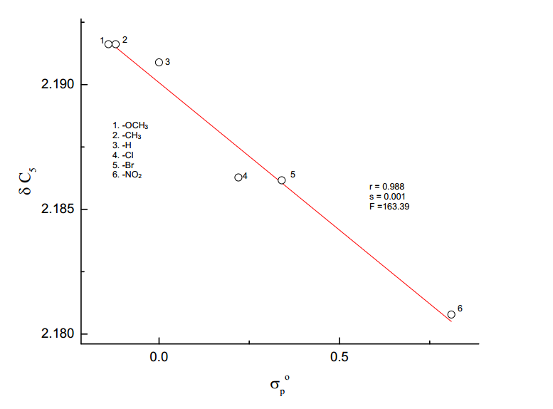

log

**Fig. 22. The plot of log δ C5 vs *σpo***

The sign of slopes *ρI* and *ρR* are negative, reveals that reverse substituent effect operates on C5 carbon atom.

The results of Yukawa-Tsuno equation (24), also indicate that the magnitude of ‘r’ is very low(< 1).

log δ C5 = -0.013 *σp* + 0.004 (*σp+- σp*) + 2.190 (24)

(±0.001) (±0.002) (±0.004)

R = 0.994; SE = 0.001; n = 7; F = 167.30

**C6 – Carbon atom**

The chemical shift of C6 carbon atom appeared over a relatively narrow range of 7.15 ppm. The results of SSP analysis shown in table (7), excellent correlation afford by σp+ constant given in equation (25), and the plot of log δ C6 vs σp+ is shown in Fig. (23).

log δ C6 = 0.018 *σp+* + 2.077 (25)

(±0.001) (±0.001)

r = 0.995; s = 0.001; n = 7; F = 508.52

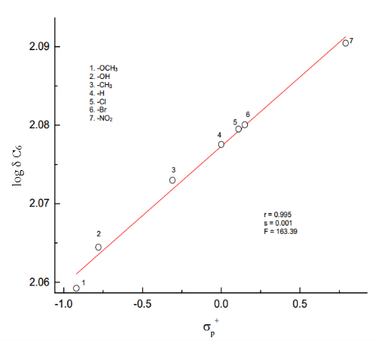

**Fig. 23. The plot of log δC6 vs *σp****+*

The results of DSP analysis in table (8), afford an excellent correlation are shown in equations (26) and (27).

log δ C6 = 0.016 *σI*+ 0.026 *σR* + 2.077 (26)

(±0.002) (±0.002) (0.001)

R = 0.996; SE = 0.001; F = 176.46; n =6

log δ C6 = 0.015*F*+ 0.032 *R* + 2.078 (27)

(±0.003) (±0.002) (0.001)

R = 0.990; SE = 0.002; F = 105.40; n =7

The sign of *ρI and ρR*  are positive, reveals that the normal substituent effect operates on C6 carbon atom, i.e., an electron withdrawing substituent decrease the C7 carbon atom shielding and an electron releasing substituent increase it. Examination of chemical shift data in table (5), electron withdrawing substituent causes downfield shift and electron releasing substituent causes upfield. The magnitude of *ρR* greater than*ρI*indicates that the predominance of resonance effect over inductive effect in the chemical shift of C6 carbon atom.

The results of Yukawa-Tsuno equation (28), also indicate that the magnitude of ‘r’ is very low (<1).

log δC6 = 0.016*σp*+ 0.021 (*σp+*- *σp*) + 2.078 (28)

(±0.002) (±0.003) (±0.001)

R = 0.996; SE = 0.001; F = 274.61; n =7

**C7 – Carbon atom**

The chemical shift of C7 carbon atom appeared over a range of about 2.3 ppm. The result of SSP analysis shown in table (7), fairly well correlation afford by *σp+/σp* constant is given in equation (29), and the plot of log δC7 vs σp+/σp is shown in

Fig. (24). The result is shown in equation (29).

log δC7 = -0.004*σp+/σp* + 2.210 (29)

(±0.001) (±0.003)

r = 0.917; s = 0.001; F = 26.41; n = 7

The examination of chemical shift data (table 5) of C7 carbon electron-releasing group causes downfield shift by increasing the shielding and electron withdrawing group cause upfield shift by decreasing the shielding. The DSP analysis of C7 carbon with various *σR* scale is shown in table (8), the best fit is given in Eq.(30)

log δC7 = -0.001*σI* - 0.008 *σR* + 2.209 (30)

(±0.001) (±0.002) (±0.001)

R = 0.928; SE = 0.001; F = 9.34; n = 6

The result of Yukawa-Tsuno equation (3), is given in table (9). The result of best fit of Eq. (3) is given in Eq. (31)

log δC7 = -0.001*σpo* - 0.005(*σp+*/ *σpo*) + 2.208 (31)

(±0.001) (±0.001) (±0.001)

R = 0.937; SE = 0.001; F = 10.76; n = 6

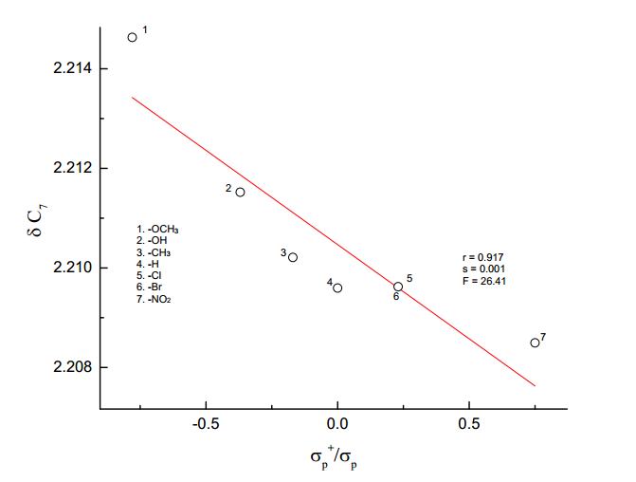

log

**Fig. 24. The plot of log δC7 vs *σp+/σp***

**C11 – Carbon atom**

The chemical shift of C11 carbon appeared over a relatively narrow range of 1.46 ppm. The SSP analysis with various σ parameters, *σp+* gave excellent correlation, results shown in table (7). It gave negative correlation (Eq.32) and negative slope indicates that a reverse substituent effect operates on the C11 carbon. The Hammett plot of log δ C11 vs *σp+* is shown in figure (25).

log δ C11 = -0.002*σp+* + 2.214 (32)

(±0.001) (±0.001)

Examination of chemical shift data in table (5) shows that the electro-releasing substituent causes downfield shift while electron-withdrawing substituent causes upfield shift. The DSP analysis of C11 carbon with various *σR* scale is given in table (8), the best fit is given in equations (33) and (34).

log δ C11 = -0.003*σI*  - 0.003 *σR* + 2.214 (33)

(±0.001) (±0.001) (±0.001)

R = 0.998; SE = 0.0001; F = 341.86; n =6

log δ C11 = -0.002*F*  - 0.004 *R* + 2.214 (34)

(±0.001) (±0.001) (±0.001)

R = 0.993; SE = 0.002; F = 152.18; n = 7

The result of Yukawa-Tsuno equation (18), is given in table (9) also indicate that the magnitude of ‘r’ is very low (<1).

log δ C11 = -0.003 *σp*  - 0.002 (*σp+ -σp*) + 2.214 (35)

(±0.001) (±0.001) (±0.001)

R = 0.993; SE = 0.002; F = 152.18; n = 7

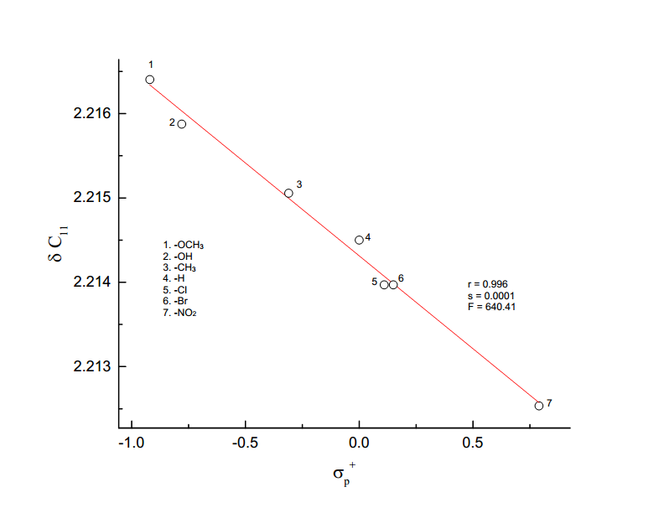

log

**Fig. 25. The plot of log δ C11 vs *σp+***

**Table (10): TSP analysis of SCS data of C22’ carbon atom of** **substituted**

**5-benzylidenebarbituric acids employing equation (4).**

|  |  |  |  |  |  |  |  |  |  |
| --- | --- | --- | --- | --- | --- | --- | --- | --- | --- |
|  |  |  |  |  |  |  |  |  |  |
| S.No. | Scale | α | β | φ | R | s | F | PR | PS |
|  |  |  |  |  |  |  |  |  |  |
| 1. | *σI ,σR,ν* | 0.019  (±0.045) | 0.084  (±0.034) | -0.007  (±0.029) | 0.895 | 0.016 | 2.68 | 76.4 | 6.40 |
|  |  |  |  |  |  |  |  |  |  |
| 2. | *σI ,σRo,ν* | -0.008  (±0.092) | 0.019  (±0.060) | 0.022  (±0.058) | 0.492 | 0.030 | 6.00 | 39.0 | 43.80 |
|  |  |  |  |  |  |  |  |  |  |
| 3. | *σI ,σR+,ν* | -0.093  (±0.071) | 0.035  (±0.023) | 0.057  (±0.035) | 0.760 | 0.155 | 1.37 | 19.2 | 31.30 |
|  |  |  |  |  |  |  |  |  |  |
| 4. | *σI ,σR-,ν* | 0.006  (±0.085) | 0.039  (±0.058) | 0.001  (±0.063) | 0.595 | 0.030 | 0.36 | 84.7 | 2.17 |
|  |  |  |  |  |  |  |  |  |  |
| 5. | *F, R, ν* | -0.001  (±0.050) | 0.078  (±0.027) | 0.005  (±0.030) | 0.904 | 0.016 | 7.00 | 92.0 | 5.95 |
|  |  |  |  |  |  |  |  |  |  |

**C22’-Carbon atoms**

The chemical shift of C22’carbon atom appearedover a relativelynarrow range of about 2.116 ppm. In the SSP analysis of C22’ *σo,*and *σo*\* gave poor correlation coefficients (r) 0.632 and 0.691 respectively. The results of SSP analysis are given in Eqs. (36) and (37).

log δ C22’ = 0.044 *σo* + 2.094 (36)

(±0.024) (±0.008)

r = 0.632; s =0.02; n =7

log δ C22’ = 0.038 *σo*\* + 2.095 (37)

(±0.020) (±0.009)

r = 0.691; s =0.02; n =6

But the same parameter for *Es* gave satisfactory correlation, given in Eq.(38)

log δ C22’ = -0.042 *Es* + 2.103 (38)

(±0.013) (±0.006)

r = 0.825; s = 0.016; n =7

The best fit of DSP analysis is given in Eqs. (39) and (40).

log δ C22’ = 0.010*σI*  + 0.079*σR* + 2.115 (39)

(±0.020) (±0.020) (±0.010)

R = 0.891; SE = 0.01; n = 6

log δ C22’ = 0.006 F + 0.081 R + 2.117 (40)

(±0.019) (±0.019) (±0.010)

R = 0.903; SE = 0.01; n = 7

The sign of slopes *ρI* and *ρR* are positive reveals that the normal substituent effects operate on C22’ carbon atom. The magnitude of *ρR*is higher than the magnitude of *ρI* indicates that the resonance effect is predominant over resonance effect on C22’ carbon atom.

The TSP analysis Charton steric parameter (ν) gave poor correlations that are given in table (10). The best fit of TSP analysis is taken from high correlation coefficient (R) and least standard error (SE) of the regression equation and the results are given in Eqs. (41) and (42).

log δ C22’ = 0.019 *σI*  + 0.084 *σR* - 0.007 ν + 2.117 (41) (±0.045) (±0.034) (±0.029) (±0.015)

R = 0.895; SE = 0.016; n = 6

log δ C22’ = -0.001F + 0.078R - 0.005 ν + 2.116 (42)

(±0.050) (±0.027) (±0.030) (±0.014)

R = 0.904, s =0.016, n = 7

A better description of the composition of the electrical effect32 is given by the equation,

PR =

PR is the percentage of delocalized effect. The result of TSP analysis is given in table (10) shows that the delocalized effect is predominant over the localized effect. The magnitude (%) of the steric factor32 is given by the equation,

PS =

The results of table (10) shows that steric effect is also operating to some extent.

**APPENDIX – I**

**Table (10): 13C SCS values for mono substituted benzenes**

|  |  |  |  |  |  |
| --- | --- | --- | --- | --- | --- |
| S.No. | Substituents | Z1(Si) | Z2 (So) | Z3 (Sm) | Z4 (Sp) |
|  |  |  |  |  |  |
| 1 | -OME | 30.2 | -14.7 | 0.9 | -8.1 |
|  |  |  |  |  |  |
| 2 | -ME | 9.3 | 0.6 | 0 | -3.1 |
|  |  |  |  |  |  |
| 3 | -H | 0 | 0 | 0 | 0 |
|  |  |  |  |  |  |
| 4 | -Cl | 6.4 | 0.2 | 1 | -2 |
|  |  |  |  |  |  |
| 5 | -Br | -5.4 | 3.3 | 2.2 | -1 |
|  |  |  |  |  |  |
| 6 | -NO2 | 19.6 | -5.3 | 0.8 | 6 |
|  |  |  |  |  |  |

**REFERENCES**

1. D.J. Craik and R.T.C. Brownlee, *Prog.Phys.Org.Chem.*,**14**,1, (1983).
2. N.B. Chapman and J. Shorter (Eds). *Advances in Linear Free Energy* *Relationships*, Plenum, London, (1972).
3. L.P. Hammett, “*Physical Organic Chemistry*” McGraw Hill Book Company, Inc., New York, (1970), Chapter VII.
4. J. Shorter, ‘Correlation Analysis in Organic Chemistry, an introduction to linear free energy relationship’, Clarenden Press, London, (1973).
5. Y. Yukawa and Y. Tsuno, Bull.Chem.Soc.., Japan, **32**, 971, (1959).
6. Fadhil, G.F. and Essa, A.H. *J. Iron. Chem.Soc*., **6**, 808, (2009).
7. R. Arulkumaran, V. Manikandan and G. Thirunarayanan, *World scientific*

*news*, **80**, 235, (2017).

1. R. Arulkumaran, V. Manikandan, P. Christhuraj and G. Thirunarayanan,

*World scientific news*, **62**, 93, (2017).

1. G. Thirunarayanan, K.G. Sekar and R. Lakshmi narayanan, *International*

*Letters of Chemistry, Physics and Astronomy*, **32**, 88, (2014).

1. M. Rajarajan, R. Senbagam, V. Vijayakumar, V. Manikandan, S.Balaji,

G. Vanangamudi and G. Thirukumaran, *World scientific news,* **9,**155, (2015).

11. Aleksandar D. marinkovic, Dominik Brkic, jelena, S.Martinkovic;

Dusanz.Mijin, Milos Milcic and Slobodan D. Petrovic, *Chemical Industry*

*and Chemical Engineering Quarterly*,**19**,67, (2013).

.

1. G. Thirunarayanan, M. Gopalakrishnan, and G. Vanangamudi, *Spectra*

*Chimica Acta*, Part A, **67**,1106, (2007).

1. G. Thirunarayanan, *Bull.Chem. Soc.Ethiop*., **28**,73, (2014).
2. Branko S. Jursic, *J. Heterocyclic. Chem*., **38**,655, (2001).

15. Gronowitz, S.; Johnson, A.; Maholanyinova, S.; Tomo and Sokaniova,

*Org.Magn.Reson.,***7**,732, (1975).

1. G.Dana,J.P. Convert, Girault and E.Mathoz, *Can.J.Chem.,***54**,1827,(1976).
2. G.J. Ray, R.J. Kurland, and A.K. Colter, *Tetrahedron,* **27**,735, (1971).
3. J.F. Hinton, and B. Layton, *Org.Magn. Reson.,* **4,353**, (1972).
4. D.J. Craik, in Annual Reports on NMR spectroscopy, ED., G.A. Webb,

*Academic Press*, London, **15**, 1, (1983).

1. B.M. Lynch, *Can. J.Chem.*, **55**,541, (1977).
2. Suppu Perumal, Rama Suppu, Chandrasekeran and Veerappan

Vijayabaskar and David,A. Wilson, *Magn.Reson.chem.,* **33**,779, (1995).

22. N. Inamoto, K. Kushida, Masuda,H.Ohta, S. Satoh, Y. Tamwa,

Tokomara,K.Tori and M. Yoshida, *Tetrahedran Lett.,* 3617,(1974).

23. J.E. Arrowsmith, M.J. Cook, and D.J. Hardstone, J. *Org.Magn.Reson.,*

**11**,160, (1978).

1. E. Solcaniova, Toma and Gronowitz, *Org.Magn.Reson.,* **8**,439, (1976).
2. M.J. Shapiro, *Tetrahedran*, **33**,1091, (1973).
3. D.A. Dawson, and W.F. Reynolds, *Can.J.Chem.* **53**,373, (1975).
4. D.A.R. Happer, *Aust.J.Chem.*, **53**,373, (1976).
5. D.A.R Happer, S.M. McKerrow, and A.L. Wilkinson, *Aust.J.Chem.*,

**2**,1479, (1973).

1. H. Gunthor, J. Prestein, and P.J. Watan, *Org.Magn.Reson.,***7**,339, (1975).
2. T.A. Modro, W.F. Renolds, and E.S. Kovupowa, *J.Chem.Soc., Perkin*

*Trans.,***2**,1479,(1977).

1. D.A.R. Happer, and.E.Steenson, *J.Chem.Soc.,Perkin Trans.,*,**2**,843,(1983).

32. M. Charton, *J.Org.Chem*.*,* **40,**407, (1975).